**CSE140 HW1, Due Mon. 4/15/2019 by 11:59PM**

# Introduction

The purpose of this assignment is three-fold. First, it aims to help you practice the application of Boolean algebra theorems to transform and reduce Boolean expressions. The second goal is to help you learn how to go from the world of Boolean expressions to the world of digital circuits. The final goal is to help you translate a problem described in words to a Boolean algebraic expression. We hope you can think of why each of these exercises is useful when designing digital circuits.

# Application of Boolean Algebra Theorems

**2.1 Prove the theorems using Boolean algebra:**

1. Prove that *A* + 1 = 1.

*Case 1: A is 0.*

*0 + 1 = 1*

*Case 2: A is 1.*

*1 + 1 = 1*

*Proof with Boolean algebra:*

*LHS = A + 1*

*= (A + 1)* ***· 1*** *->identity law*

*= (A + 1) ·* ***(A + A’)***  *->complement law*

*=* ***A + (1*** *·* ***A’)*** *->distributive law*

*= A +* ***A’*** *->identity law*

*=* ***1*** *= RHS ->complement law*

1. Prove that *A* · 0 = 0.

*Case 1: A is 0.*

*0 · 0 = 0*

*Case 2: A is 1.*

*1 · 0 = 0*

*Proof with Boolean algebra:*

*LHS = A · 0*

*=* ***(A · 0) + 0*** *->identity law*

*= (A · 0) +* ***(A · A’)*** *->complement law*

*=* ***A*** *·* ***(0 + A’)*** *->distributive law*

*= A ·* ***(A’ + 0)*** *->commutative law*

*= A ·* ***(A’)*** *->identity law*

*= A ·* ***A’***

*=* ***0*** *= RHS* *->identity law*

**2.2 Prove the following equations using Boolean algebra:**

1. *a*’*b* + *a*’*cd*’ + *b*’*cd*’ = *a*’*b* + *b*’*cd*’.

*LHS = a’b + a’cd’ + b’cd’*

*= a’b + a’cd’* ***· 1*** *+ b’cd’ ->identity law*

*= a’b + a’cd’ ·* ***(b + b’)*** *+ b’cd’ ->complement law*

*= a’b +* ***a’bcd’ + a’b’cd’*** *+ b’cd’ ->distributive law, associative law*

*=* ***a’b(1 + cd’) + b’cd’(1 + a’)*** *->distributive law, associative law*

*= a’b ·* ***1*** *+ b’cd’ ·* ***1*** *->2.1A, commutative law*

*=* ***a’b + b’cd’*** *= RHS ->identity law*

1. *(a’ + b)(a’ + c + d’ + e)(b’ + c + d’) = (a’ + b)(b’ + c + d’).*

*LHS = (a’ + b)(a’ + c + d’ + e)(b’ + c + d’)*

*= (a’ + b)((a’ + c + d’ + e)* ***+ 0****)(b’ + c + d’)*

*->identity law*

*= (a’ + b)((a’ + c + d’ + e) +* ***(b · b’))(****b’ + c + d’)*

*->complement law*

*= (a’ + b)****(a’ + b + c + d’ + e)(a’ + b’ + c + d’ + e)****(b’ + c + d’)*

*->distributive law, associative law*

*=* ***((a’ + b) + ((c + d’ + e) · 0))(((a’ + e) · 0) + (b’ + c + d’))***

*->null element law*

*= ((a’ + b)* ***+ 0****)(****0 +*** *(b’ + c + d’))*

*->2.2B*

*=* ***(a’ + b)(b’ + c + d’)*** *= RHS ->identity law*

Are the above equations related to the consensus theorem?

Yes, for A, a’cd’ is a consensus, as a’ is a product of the a’b minterm and cd’ is a product of the b’cd’ minterm and thus equivalent to the expression without it.

B is also related as one product is eliminated.

**2.3 Prove the above two equations using Shannon’ expansion.**

A.

*Our LHS is a’b + a’cd’ + b’cd’. Show it is equivalent to a’b + b’cd’*

*f(a, b, c, d) = a’b + a’cd’ + b’cd’*

*= bf(a, 1, c, d) + b’f(a, 0, c, d) ->shannon’s expansion*

*= b(a’1 + a’cd’ + 1’cd’) + b’(a’0 + a’cd’ + 0’cd’) ->””*

*= b(a’ + a’cd’) + b’(a’cd’ + cd’) ->identity, 2.1b*

*= a’b + a’bcd’ + a’b’cd’ + b’cd’ ->distribution*

*= a’b(1 + cd’) + b’cd’(1 + a’) ->distribution*

*= a’b(1) + b’cd’(1) ->2.1A*

*= a’b + b’cd’ = RHS ->identity*

B.

*Our LHS is (a’ + b)(a’ + c + d’ + e)(b’ + c + d’). Show = (a’ + b)(b’ + c + d’).*

*f(a, b, c, d, e) = (a’ + b)(a’ + c + d’ + e)(b’ + c + d’)*

*->shannon’s expansion*

*= (b + (a’ + 0)(a’ + c + d’ + e)(0’ + c + d’))(b’ + (a’ + 1)(a’ + c + d’ + e)(1’ + c + d’)) ->shannon’s expansion*

*= (b + (a’)(a’ + c + d’ + e))(b’ + (a’ + c + d’ + e)(c + d’))*

*->identity, 2.1A*

*= (b + (a’))(b’+(c + d’))*

*->a(a + b) = a*

*= (a’ + b)(b’ + c + d’) = RHS ->associative*

# From Problem to Boolean Expression

A circuit has four inputs and one output. The inputs (*a*3*,a*2*,a*1*,a*0) represent a number from 0 to 15. Output *Y* is true if the number is prime (0 and 1 are not prime, but 2, 3, 5 and so on are prime). A. Describe the truth table.

|  |  |  |  |  |
| --- | --- | --- | --- | --- |
| *a*3 | *a*2 | *a*1 | a0 | **Y** |
| 0 | 0 | 0 | 0 | **0** |
| 0 | 0 | 0 | 1 | **0** |
| 0 | 0 | 1 | 0 | **1** |
| 0 | 0 | 1 | 1 | **1** |
| 0 | 1 | 0 | 0 | **0** |
| 0 | 1 | 0 | 1 | **1** |
| 0 | 1 | 1 | 0 | **0** |
| 0 | 1 | 1 | 1 | **1** |
| 1 | 0 | 0 | 0 | **0** |
| 1 | 0 | 0 | 1 | **0** |
| 1 | 0 | 1 | 0 | **0** |
| 1 | 0 | 1 | 1 | **1** |
| 1 | 1 | 0 | 0 | **0** |
| 1 | 1 | 0 | 1 | **1** |
| 1 | 1 | 1 | 0 | **0** |
| 1 | 1 | 1 | 1 | **0** |

1. Write the function in sum-of-products canonical form.

Y = *a*3’ *a*2’ *a*1 *a*0’ + *a*3’ *a*2’ *a*1 *a*0 + *a*3’ *a*2 *a*1’ *a*0 +

*a*3’ *a*2 *a*1 *a*0 + *a*3 *a*2’ *a*1 *a*0 + *a*3 *a*2 *a*1’ *a*0

1. Write the function in product-of-sums canonical form.

Y = ( *a*3’ + *a*2’ + *a*1*’* + *a*0’ ) *·* ( *a*3’ + *a*2’ + *a*1*’* + *a*0 ) *·* ( *a*3’ + *a*2 + *a*1*’* + *a*0’ ) *·* ( *a*3’ + *a*2+ *a*1+ *a*0’ ) *·* ( *a*3+ *a*2’ + *a*1*’* + *a*0’ ) *·* ( *a*3+ *a*2’ + *a*1*’* + *a*0 ) *·* ( *a*3+ *a*2’+ *a*1 *+ a*0’ ) *·* ( *a*3+ *a*2+ *a*1’+ *a*0’ )*·*( *a*3+ *a*2+ *a*1+ *a*0’ ) *·* ( *a*3+ *a*2+ *a*1+ *a*0 )

# Boolean Algebra and Implementation

1. Simplify each of the following two Boolean equations (using Boolean algebra, in particular consensus theorem).
2. Sketch a reasonably simple combinational circuit implementing the simplified equation.
3. List the numbers of literals and operators versus the numbers of gates, nets, and pins in the schematic diagrams
4. *y*(*a,b,c,d*) = *ac*’*d*’ + *ab*’*cd*’ + *a*’*bcd*’ + *bd* + *a*’*bc*’*d* + *abc*

*= ac’d’ + ab’cd’ + a’bcd’ + bd(1 + a’c’) + abc ->distribution*

*= ac’d’ + ab’cd’ + a’bcd’ + bd + abc ->2.1A, identity*

*= (abc +* ***abd’*** *+ ac’d’) + ab’cd’ + a’bcd’ + bd ->consensus, associative*

*= abc + ac’d’ + (abd’ +* ***acd’*** *+ ab’cd’) + a’bcd’ + bd ->consensus, assoc*

*= abc + ac’d’ + abd’ + acd’(1 + ab’cd’) + a’bcd’ + bd ->distribution*

*= abc + ac’d’ + abd’ + acd’ + a’bcd’ + bd ->2.1A, identity*

*= abc + (ac’d’ +* ***ad’*** *+ acd’) + abd’ + a’bcd’ + bd ->consensus, assoc*

*= abc + ad’(1 + c’ + c) + abd’ + a’bcd’ + bd ->distribution*

*= abc + ad’ + abd’ + a’bcd’ + bd ->2.1A, identity*

*= abc + (ad’ +* ***ab*** *+ bd) + abd’ + a’bcd’ ->consensus*

*= abc + ad’ + ab + bd + (abd’ +* ***bcd’*** *+ a’bcd’) ->consensus*

*= ad’ + ab(1 + c + d’) + bd + bcd’ + a’bcd’ ->distribution*

*= ad’ + ab + bcd’ + bd + a’bcd’ -2.1A, identity*

*= ad’ + ab + bcd’(1 + a’) + bd ->distribution*

*= ad’ + ab + bcd’ + bd ->2.1A, identity*

*= ad’ + ab + (bd +* ***bc*** *+ bcd’) ->consensus*

*= ad’ + ab + bd + bc(1 + bcd’) ->distribution*

*= ad’ + ab + bd + bc ->2.1A, identity*

*= ad’ + bd + bc ->consensus*

***No. of***

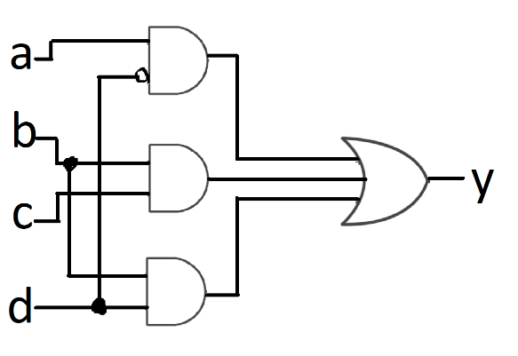***literals: 6***

***operators: 4***

***gates: 4***

***nets: 8*** *= vars + ops = 4 + 4*

***pins: 13*** *= literals + 2*operators – 1 = 6 + 2*4 - 1*

1. (*b*’ + *ac*)(*a*’*c*’ + *b*)(*ab* + *c*)’

*= (b’ + ac)(a’c’ + b)(ab)’c’ ->demorgan’s*

*= (b’ + ac)(a’c’ + b)(a’ + b’)c’ ->demorgan’s*

*= (b’ + ac)(a’c’ + b)* ***(a’c’ + a’)*** *(a’ + b’)c’ ->consensus*

*= (b’ + ac)(a’c’ + b)(a’(1 + c’))(a’ + b’)c’ ->distribution*

*= (b’ + ac)(a’c’ + b)(a’)(a’ + b’)c’ ->2.1A, identity*

*= (b’ + ac)(a’c’ + b)(a’a’ + a’b’)c’ ->distribution*

*= (b’ + ac)(a’c’ + b)(a’ + a’b’)c’ ->identity*

*= (b’ + ac)(a’c’ + b)(a’(1 + b’))c’ ->distribution*

*= (b’ + ac)(a’c’ + b)(a’c’) ->2.1A, identity, associative*

*= (b’ + ac)(a’c’a’c’ + a’c’b) ->distribution, commutative*

*= (b’ + ac)(a’c’ + a’c’b) ->identity*

*= (b’ + ac)(a’c’(1 + b)) ->distributive*

*= (b’ + ac)(a’c’) ->2.1A, identity*

*= a’b’c’ + aa’cc’ ->distributive*

*= a’b’c’ ->complement*

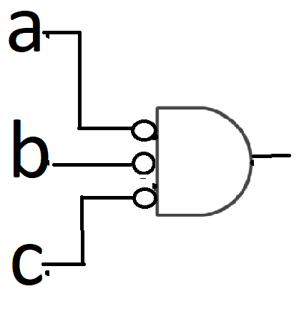

***No. of***

***literals: 3***

***operators: 1***

***gates: 1***

***nets: 4*** *= vars + ops = 3 + 1*

***pins: 4*** *= literals + 2*operators – 1 = 3 + 2*1 - 1*